Below is the list of plugins as per their respective source type.

|  |  |  |
| --- | --- | --- |
| Plugin Id | Source Name | Plugin Name |
| 41 | Proxy Statement 14 A | OWNERSHIP_EXTRACTOR.OwnershipExtractorPlugin |
| 42 | 10 K | OWNERSHIP_EXTRACTOR.OwnershipExtractorPlugin |
| 43 | FORM ADV | ownership.us.FormAdvExtractionPlugin |
| 44 | Annual Report | OWNERSHIP_EXTRACTOR.OwnershipExtractorPlugin |
| 45 | Annual Filing | attribute.uk.AnnualFilingExtractionPlugin |
| 46 | Confirmation Statement | attribute.uk.ConfirmationStatementOwnershipPlugin |
| 47 | Annual Report | attribute.us.SubsidiaryExtractionplugin |
| 48 | Annual Filing | attribute.us.SubsidiaryExtractionplugin |
| 49 | 10 K | attribute.us.SubsidiaryExtractionplugin |
| 50 | Exhibit 21(10 K) | attribute.us.SubsidiaryExtractionplugin |
| 51 | NA | attribute.us.PrivateDataExtractionPlugin |

The above mentioned all plugins getting executed as per source document downloaded in the application and gets the ownership details.

Below are the two services used to get ownership details,

<http://localhost:8090/getSubsidiaryHoldingPercentage>

<http://localhost:8080/RegionExtractor/EKYC/callOCR>

If these services have not extracted the ownership details in it’s response then there is no ownership details on UI shown.

As per **JPMC** the ownership details are getting extracted from source **Annual Filling** and **Annual Report** and their respective Plugin name for both source is **attribute.us.SubsidiaryExtractionplugin.**

Below are the screen shots for ownership details section,

**Citi**:- Not showing ownership details for entity for entity ‘**BP CAPITAL MARKETS PLC’**:-

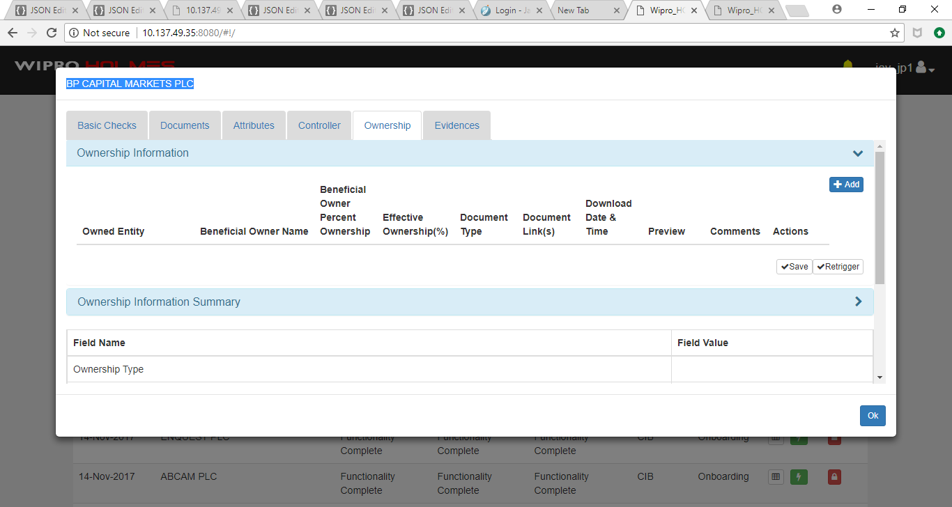

**Jpmc** :- showing ownership details for entity ‘**BP CAPITAL MARKETS PLC’**,

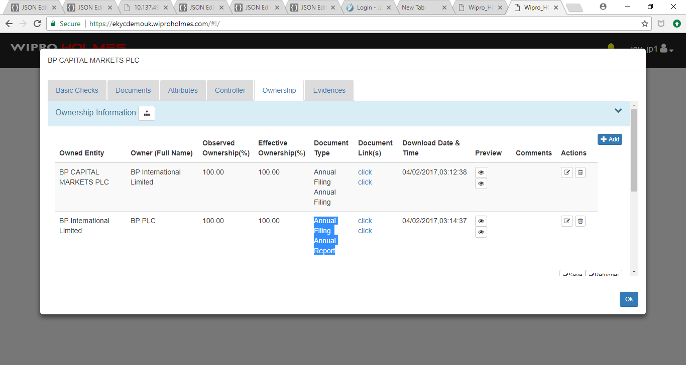

After DB changes with respect to plugin **attribute.us.SubsidiaryExtractionplugin** as selected 1 we are getting ownership details for following entities,

|  |  |  |  |
| --- | --- | --- | --- |
| Sr No | Entity Name | Souce Type | Current Status |
| 1 | BP CAPITAL MARKETS PLC | Annual Filling | Ownership details are coming properly in DEV UK and SIT UK |
| 2 | SCOTLAND GAS NETWORKS PLC | Annual Filling | only one correct ownership detail for 'Scotia Gas Networks Limited' are cming but in jpmc having total 2 ownership details, other 1 is 'OMERS Administration Corporation' which is not coming |
| 3 | PRUDENTIAL CAPITAL PUBLIC LIMITED COMPANY | Annual Filling | only one correct ownership detail for 'Prudential Capital Holding Company Limited' is coming but in jpmc having total 3 ownership details, other 2 are 'Prudential plc' and Prudential Group' are not coming. |
| 4 | ROAD MANAGEMENT SERVICES (FINANCE) PLC | Annual Filling | not working  in jpmc 'Road Management Services (Darrington) Limited' and 'Road Management Services (Darrington) Holdings Limited' |
| 5 | SPIRE HEALTHCARE LIMITED | Annual Filling | Not working |
|  | SCHOLL LIMITED | Annual Filling | Not working |

Working details are coming properly for entity ‘BP CAPITAL MARKETS PLC’ in DEV and SIT both for UK. Please refer below screen shot for the same,

**DEV UK:-**

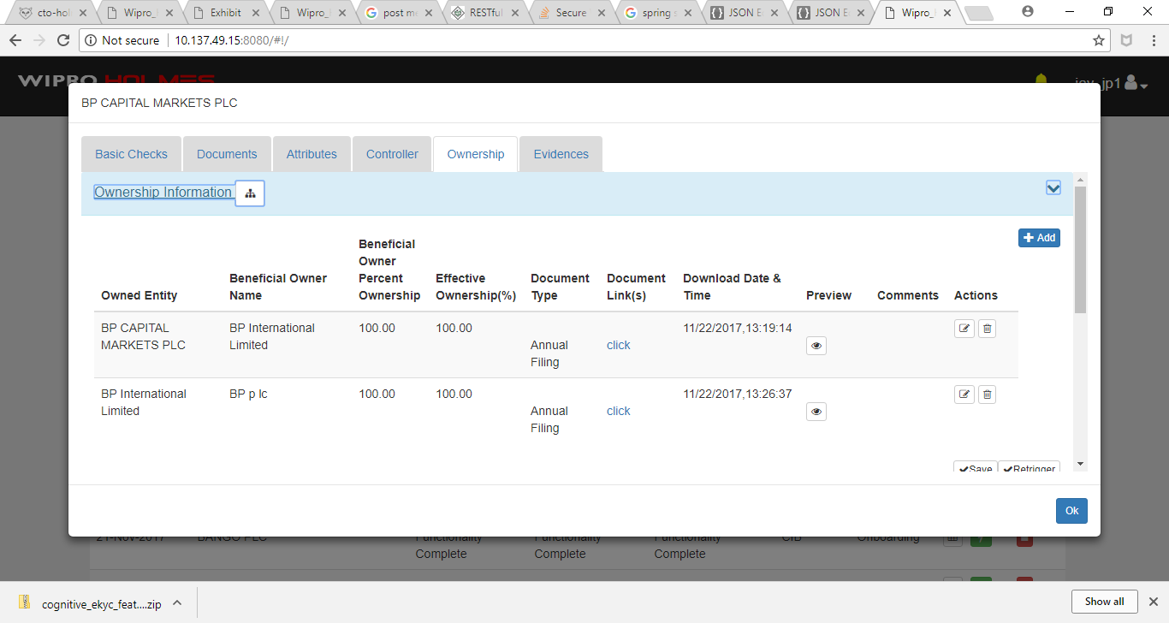

**SIT UK:-**



